The Honors Council

WHO WE ARE
The Honors Council is comprised of a group of dedicated honors students who assume the most important leadership roles within the Pforzheimer Honors College. The council serves as a venue for honors students to explore their leadership abilities in addition to planning and organization skills. The Honors Council consists of a President, Vice-president, Secretary, and Treasurer who are elected to office by the students in the Honors College during the Spring semester. We work diligently to organize events and activities that benefit Honors students and help foster a sense of community within the Honors College. We conduct open meetings with the honors community and serve as a liaison between the honors students and the staff of the Honors College.

WHAT WE DO
The Honors Council’s goal is to create a sense of community for Honors students. We are passionate about advocating for our members, whether it be desired events, interactions with professors, or supporting the Honor’s College’s agenda forward. We are receptive to the ideas of our members and strive to seek positive outcomes. Our events focus on personal development, socialization, and community service.

HOW TO GET INVOLVED
As an honors student you can participate in all our events and activities. Share your ideas and opinions at the monthly open meetings. Write an article about your experiences for our newsletter, Scholastica. Be an active member of our community!

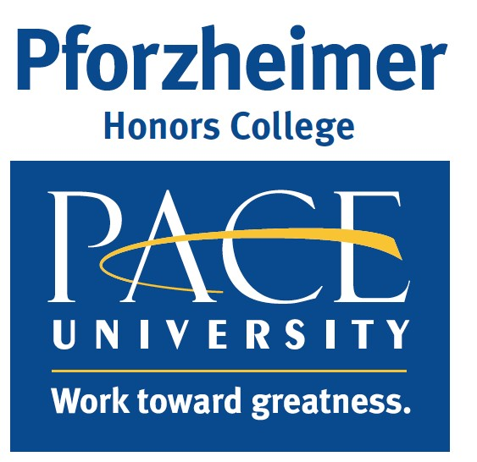
Contact the 2017-2018 Council Members

President: Mariah Palagyi
mp01898p@pace.edu
Vice-President: Mackenizie Dolishny md33977p@pace.edu
Secretary: Deana Conzuegra dc06509p@pace.edu
Treasurer: Kamari Stewart ks27020p@pace.edu

