Pace University’s Collegiate Recovery Community Resource Page

Dear Pace University Student:
Welcome to your Pace experience and to the Collegiate Recovery Community Resource Page!! Our goal is to help you make your experience at Pace as productive as possible by helping to prevent the negative consequences of alcohol or drug use- yours or someone else’s.
The Collegiate Recovery Community (CRC) mission is to provide students with advocacy and assets so that each student will be able to achieve the fullness of the college experience. Together we will help create collegiate sobriety and recovery programs and practices so that students can thrive in the college experience while maintaining a state of well-being. Our goals are to connect students with one another who both supports recovery and abstinence allowing them to form bonds and friendships for this common cause while also enhancing their experiences and social networks.
What is the Collegiate Recovery Community Resource Page? The Collegiate Recovery Community Resource Page is a group of documents and external links created for students in order to teach knowledge of the risks of alcohol and other drugs. The page includes:

- A BAC (Blood Alcohol Concentration) chart showing safer quantities of alcohol consumption if you do choose to drink;

- Underage Drinking- Problem Fact Sheet from the Center for Disease Control

- An information sheet on marijuana use: Marijuana- How Much Is Too Much?;

- A Prescription Drug Abuse Tip Sheet

What is Pace Prevention Programming? Pace Prevention Programming are events held throughout the year that provide students with needed information to help prevent AOD (Alcohol and Other Drugs) problems. These include:
- Oksoberfest: Held jointly by Residence Life and the Counseling Center each October, Oksoberfest consists of an information table in 1 Pace Plaza, to give out information, snacks, and fun items that support students’ making healthier decisions around alcohol and drug use, and evening programming events in the residence halls.

- Wellness Week Events: Each spring, Pace holds a week of special programming to promote students’ making healthy decisions, including choices regarding AOD use.

- Residence Hall Programming: Programs on specific AOD topics and related issues, such as sexual assault, which are held throughout the semester in the residence halls.

- AOD Limited Assessments: Students in violation of Pace’s AOD Policy may be referred to the Counseling Center for an AOD Limited Assessment, to help determine the nature and extent of the student’s AOD problem and to make appropriate treatment referrals for students in need of AOD treatment.

- Collegiate Recovery Community Program: Support for students in recovery from alcohol and drug abuse issues.

Helpful Resources
- Ideas to text friends if you want to “escape” from a situation (or help your friend escape) when you realize you/they might be in danger because of alcohol/other drugs:
“Hey, come get me, I need to tell you something ASAP.”
“Hey, please come outside to help find lost keys or wallet.”
“Let’s go out to smoke.” (regardless of whether they smoke or not) as a way to reconvene outside.
“Hey, you will not believe what just happened. Come get me ASAP!”
…[customize your own text message!]

- List of free AOD apps and websites:

APPS
- ShowMeMyBuzz: Easy to use table helps you calculate if you can expect a hangover, if you are buzzed, and if you can be expected to be safe to drive, etc., based on your input (your weight, how much alcohol you had and within which span of time). You should also input your gender so that results are more accurate.

- RecoveryNow: Different addiction topics, such as causes of addiction, symptoms, and possible treatments, in addition to news related to AOD awareness.

- Teen Hotlines: Multiple hotlines for diverse needs such as AOD, and others, for example, AIDS and HIV, Bullying and Cyberbullying, Depression, Eating Disorders, among many others.
Websites
- Alcohol- Wise, Under the Influence, and Marijuana 101: Access them via Pace website, Counseling Center section. Great tools to assess alcohol and marijuana use.

- http://www.drugsmeter.com/

- http://www.drugfreeworld.org/

- Alcohol Calorie Counter:

- http://www.collegedrinkingprevention.gov/collegestudents/calculator/alcoholcalc.aspx

- Alcohol Costs Counter:
http://www.collegedrinkingprevention.gov/CollegeStudents/calculator/calculator.aspx

- Party & Club Drugs: http://www.drugabuse.gov/drugs-abuse/club-drugs

- The Cool Spot! http://thecoolspot.gov/

- And many more at http://www.bestofhealth.org/Top100+/Drugs__Alcohol/index.html

Alcohol Harm Reduction: Know Yourself! **
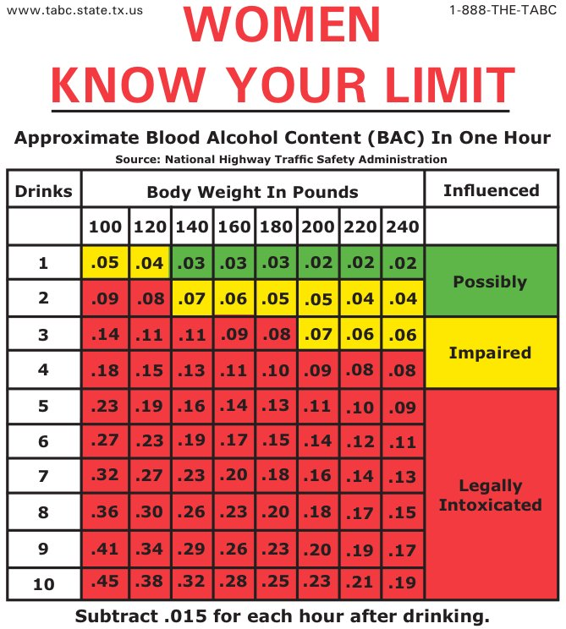
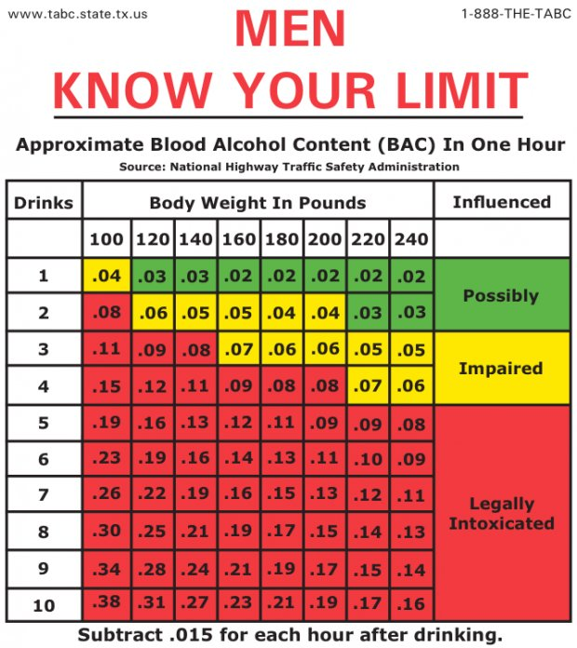
A driver who is less than 21 years of age and who drives with a .02 BAC to .07 BAC violates the Zero Tolerance Law.

**This information was taken from the Business Insider Website

Underage Drinking Problem Fact Sheet**

Underage Drinking
Alcohol use by persons under age 21 years is a major public health problem. Alcohol is the most commonly used and abused drug among youth in the United States, more than tobacco and illicit drugs, and is responsible for more than 4,300 annual deaths among underage youth. Although drinking by persons under the age of 21 is illegal, people aged 12 to 20 years drink 11% of all alcohol consumed in the United States. More than 90% of this alcohol is consumed in the form of binge drinks. On average, underage drinkers consume more drinks per drinking occasion than adult drinkers. In 2010, there were approximately 189,000 emergency rooms visits by persons under age 21 for injuries and other conditions linked to alcohol.

Drinking Levels among Youth
The 2013 Youth Risk Behavior Survey found that among high school students, during the past 30 days
- 35% drank some amount of alcohol.
- 21% binge drank.
- 10% drove after drinking alcohol.
- 22% rode with a driver who had been drinking alcohol.
Other national surveys
- In 2012 the National Survey on Drug Use and Health reported that 24% of youth aged 12 to 20 years drink alcohol and 15% reported binge drinking.
- In 2013, the Monitoring the Future Survey reported that 28% of 8th graders and 68% of 12th graders had tried alcohol, and 10% of 8th graders and 39% of 12th graders drank during the past month.

Consequences of Underage Drinking
Youth who drink alcohol are more likely to experience
- School problems, such as higher absence and poor or failing grades.
- Social problems, such as fighting and lack of participation in youth activities.
- Legal problems, such as arrest for driving or physically hurting someone while drunk.
- Physical problems, such as hangovers or illnesses.
- Unwanted, unplanned, and unprotected sexual activity.
- Disruption of normal growth and sexual development.
- Physical and sexual assault.
- Higher risk for suicide and homicide.
- Alcohol-related car crashes and other unintentional injuries, such as burns, falls, and drowning.
- Memory problems.
- Abuse of other drugs.
- Changes in brain development that may have life-long effects.
- Death from alcohol poisoning.
In general, the risk of youth experiencing these problems is greater for those who binge drink than for those who do not binge drink.
Youth who start drinking before age 15 years are five times more likely to develop alcohol dependence or abuse(http://www.cdc.gov/alcohol/faqs.htm#alcoholismAbuse) later in life than those who begin drinking at or after age 21 years.

Prevention of Underage Drinking
Reducing underage drinking will require community-based efforts to monitor the activities of youth and decrease youth access to alcohol. Recent publications by the Surgeon General and the Institute of Medicine outlined many prevention strategies that will require actions on the national, state, and local levels, such as enforcement of minimum legal drinking age laws, national media campaigns targeting youth and adults, increasing alcohol excise taxes, reducing youth exposure to alcohol advertising, and development of comprehensive community-based programs. These efforts will require continued research and evaluation to determine their success and to improve their effectiveness.
**This information was taken from the Center for Disease Control Website

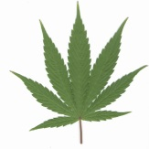 Marijuana: How Much Is Too Much?* 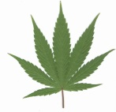
In New York State possession of any amount of non-medical marijuana is illegal, so by law any use of marijuana is too much use. Penalties for possession vary according to the amount possessed. Even if your home state has a medical marijuana law that applies to you, you are required to abide by New York State law when at Pace University.
If you choose to use marijuana anyway, below is some important information.
If you can answer “yes” to any of the following questions, then your use of marijuana is TOO MUCH:
Is it hard to imagine your life without marijuana?
Has smoking pot become a burden, or has stopped being fun?
Do you fall short of doing what is normally expected of you because of using marijuana (including class, work, social or family obligations)?
Do you wake and bake (smoke first thing in the morning)?
Has someone else suggested you cut down on your use, or expressed concern about your use, such as a family member, friend, doctor?
Do you smoke marijuana to avoid dealing with problems or stress, or to prepare yourself to deal with such problems?
Have you tried cutting down or stopping your marijuana use altogether, but found you eventually resumed use?
Do you sometimes deal marijuana on the side to cover the costs of your use?
Do you hang out only with people who get high?
Have you begun to lose interest in things that used to matter to you, such as schoolwork, friends, hobbies, or friends who don’t use marijuana or alcohol?
When your stash is empty, do you feel anxious or worried about how to get more?
Do you want to continue using even after your friends say that they’ve had enough marijuana?
Have you experienced severe anxiety or panic after using marijuana?
Do you use marijuana regularly before classes or before or during work?
Note: In Pace’s residence halls or elsewhere on Pace property, any amount of marijuana is too much, as the possession of marijuana is a violation of Pace policy (and, of course, a violation of New York State law).
If you answered “yes” to any of these questions, speak with your RA about getting help, or come to the Pace Counseling Center, 156 William Street 8th floor, 212-346-1526.
*Adapted from “How Much Is Too Much”, Facts On Tap, http://www.factsontap.org

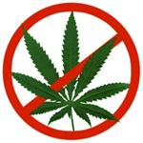 Some Interesting Info About Marijuana*:
Interference with Academic Functioning: Heavy users of marijuana have been found to have reduced blood flow to the brain, and impairment of short-term memory, attention, and integration of complex information. Students who used marijuana 5 times of more in the past year reported they overslept and missed a class at least once; 40% of them also reported concentration problems.** Clearly, these are all capacities that students need to have functioning at their best in order to make the most of their time in college. The joke about college students who are heavy marijuana users may be well founded: “College Was the Best 6 Years of My Life”. Adolescents and young adults who use marijuana heavily have shown poorer educational outcomes, lower incomes, higher unemployment, and lower satisfaction in relationships and life overall.
Effects on mental health: Heavy use has been associated with acute panic reactions and acute paranoia. Daily use can be a trigger for severe mental illness. Daily users may have a 5 times greater likelihood of becoming depressed and a 30% greater likelihood of developing schizophrenia.
Pharmacologic Effects of Marijuana Use: Psychomotor, behavioral and cognitive effects: object distance distortion, object outline distortion, inability to make rapid judgment, slowed reaction time, impaired visual tracking, slowed time perception.
Longer term effects: Even after stopping marijuana use for 28 days, diminished activation of motor cortical circuits in the brain has been seen.
Other Risks and Problems with Using Marijuana : Many people think smoking marijuana is harmless to their health because it’s “natural”. Lots of things are “natural” but you probably wouldn’t want to ingest them or inhale them into your lungs (volcanic fumes, hemlock, salmonella bacteria, etc.). Did you know that if you smoke 3 joints you will inhale the same amount of toxic chemicals as in a whole pack of cigarettes? Cannabis smoke contains 7 times more tar and carbon monoxide than cigarette smoke.
For more information about marijuana, alcohol and other drugs, visit the Pace Counseling Center website and use the e-Chug and e-Toke online assessment tools and other information found there, or visit us at the
Pace Counseling Center, 156 William Street 8th floor, 212-346-1526.
http://www.pace.edu/counseling-center/
*Adapted from the New York State Office of Alcoholism and Substance Abuse Services
** Center for Substance Abuse Research, January 21, 2008. University of Maryland, College Park.

Pace University Counseling Center:
Prescription Drug Abuse
- Prescription drug abuse is the intentional use of medication without a prescription; in a way other than as prescribed; of for the experience or feeling it causes.
- Prescription medications such as pain relievers, sedatives, and stimulants can improve health and help people to lead productive lives. However, when they are not taken as directed, these medications can become addictive and have life-threatening implications
- In 2014 the Pace CORE Survey found that …. 14.5% of Pace Students abused stimulants and 18.1% of Pace Students abused benzodiazepines
Three categories that prescription drugs fall under: Opiods, Depressants, and Stimulants:
Opiods:
Vidcodin, Oxycotin, Percocet
Use: Prescribed for their analgesic properties to manage pain effectively.
Effects: Affects regions of the brain that trigger euphoria
Signs of Abuse: Drowsiness, Constipation, Slowed Breathing, Low Blood Pressure, Respiratory Depression
Depressants:
Valium, Xanax, Ambien
Use: Anxiety, Tension, Panic Attacks, Sleep Disorders, Acute Stress Reactions
Effects: Increase GABA in the brain, decreases brain activity producing calming effect
Signs of Abuse: Drowsiness, Poor Judgment, Dangerous Withdrawal Symptoms, Respiratory Depression
Stimulants:
Adderall, Ritalin, Concerta
Use: Treatment of narcolepsy, depression, ADHD
Effects: Increases alertness, attention, and energy
Signs of Abuse: Psychosis, Seizures, Cardiovascular Complications (Dangerous increases in blood pressure, heart rate, respiration)
_________________________________________________
Myth: EVERYONE IS DOING IT.
From our CORE survey results, we know that 69.2% of Pace students said they prefer not to have drugs available at parties they attend on and off campus.
_________________________________________________
Recognize the signs:
- Using medication more frequently or at higher doses without a physician’s instruction
- Using medication compulsively
- Not being able to complete normal daily tasks because of drug misuse
_______________________________________________________
For more information please contact:
Pace Counseling Center
156 William Street
New York, New York 10038
(212) 346 1526

