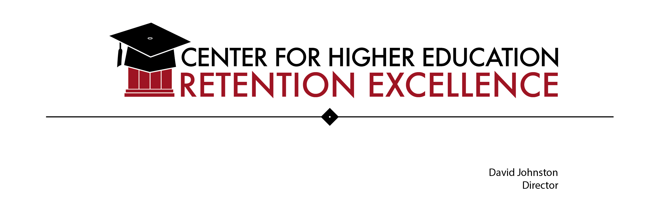

Retention Practices Gleaned from Multiple Sources – compiled by David Johnston, 2016-2017

Background

Retention – the persistence of students from enrollment to graduation – results from many factors that occur over time. The “big picture” for retention is a continuum that links K-12 education to higher education that recognizes “risk factors” inherent to underrepresented children and youth that are often not eliminated when those youth enroll in some type of higher education. Efforts to address this achievement gap – sometimes called an “opportunity gap” – need to be viewed on a continuum requiring collaboration among public and private sector partners, and where no one partner (e.g., state government, public schools, public colleges and universities) can dictate strategies. Many of the elements of a long-term, comprehensive “retention/persistence plan,” an overall coordinating mechanism notwithstanding, could include the following:

Before College
- Bridge programs for incoming freshmen, or younger, ideally on campus -- that combine skill-building, assessment, deficit reduction, and fun. An overnight stay, or a multi-week, on-campus summer experience goes a long way toward increasing first generation comfort level.
- Dual enrollment/”Early College” – exposing high school students to college-level work and instructors through partnerships between a campus and one or more feeder high schools.
- Assessment of “college readiness” in multiple ways, including less emphasis on SAT, ACT and/or Accuplacer, and more on high school GPA, attendance, behavior, and sometimes the earned reputation of the high school. Documenting “achievement gaps” is a negative but necessary part of such assessment.
- Financial Aid: Careful, individually tailored help to complete the FAFSA, explore scholarship possibilities, and meet the financial aid requirements of each student’s target schools.
- Application of “predictive analytics” to help campuses look at the risk factors of incoming students to anticipate challenges facing individual students and fashion support services to better address those challenges.
- Seamless Counseling – encouraging challenged high school students to participate in a community-based organization (CBO) that helps them finish their senior year, find an appropriate higher education choice (2-year college, 4-year college, technical certificate program), survive “summer melt,” successfully matriculate, and then support them, as needed, through to graduation. Such CBOs often train and assign mentors to target students for multi-year assignments.

- Mentors: Ideally, every “challenged” student in K-12, but especially in high school would benefit from a skilled mentor if there was an ample supply, based more or less on the Career Beginnings model practiced at the Hartford Consortium for Higher Education for many years – trained mentors backed up by HCHE staff who begin working with selected Hartford students at the beginning of 12th grade and continue to support them through their first two years of college (“seamless counseling”).
- Emphasis on reading and writing – in addition to the documented importance of “Reading by Three”about the importance of challenged kids reading “at grade level” by the end of third grade (see widely cited study by the Casey Foundation), a continuous push re. reading is a critical factor in preventing significant achievement gaps by the time students graduate high school. (See “The Writing Revolution,” by Peg Tyre, in the October 2012 edition of The Atlantic, re. a challenged high school that re-oriented its entire curriculum, except math, on writing.) A good mentor should be encouraging reading and writing.
- Managing social media: Young people, and some older people, love their communications technology, especially smartphones; but their prevalence and addictive power inhibit learning, especially reading and writing. Parents and teachers of K-12 students need to set limits, and students in both K-12 settings and in higher education need to be taught to balance their use with in-depth reading and writing, and to learn how to live without them occasionally. (See “Stop Googling, Let’s Talk,” New York Times Magazine, by Sherry Turkle.)
- Gap Year: An idea, a retention strategy now coming into its own (see Chronicle of Higher Education, June 8th, “The Best Freshman Year is a Gap Year,” p. A13) – an opportunity for students, perhaps burned out by high school and the pressure to get into college, to engage in something meaningful. An increasing number of colleges and universities are helping admitted students pursue gap years, and some have developed scholarship funds to open this to lower-income students – a proven retention factor.
Summer After Graduation
- Summer melt prevention, via a funded program that employs and trains recent college graduates who help recent high school graduates meet their higher education enrollment requirements (e.g., financial aid, housing deposits) and stay focused on their futures.

- Seamless Counseling continued.

Freshman Year

- During orientation, an “Envisioning Your Future” exercise (on-line or in a freshman group), including an essay on “how and why I did well in my freshman year” (hypothetical) – per Univ. of Texas Austin.

- Seamless Counseling continued, via a continued support person/mentor, or an on-campus mentor.

- Continued application of predictive analytics

- Learning Communities promote campus engagement, potentially link students to a major or even a career direction, and create a cohort of like-minded students that nurture peer learning. Residential learning communities, where feasible, are especially effective and linked to higher retention and graduation. (See “Adding Value: Learning Communities and Student Engagement,” by Chun-Mei Zhao and George D. Kuh.)

- Posse-Type Cohort Groups: have been shown to promote retention among students sharing similar backgrounds. “I found a mentor (from an organization) who looks like me.”

- Quality First Year Experience program and/or involvement in a “Learning Community” (to build an immediate peer group that functions at both the academic and personal levels) – ideally, required. (Cite numerous reports from the National Center for First Year Experience.)

- Embedded support: freshmen take regular intro courses (e.g, English and/or Math 101), supplemented by additional, intensive work outside regular class time, all for credit – replacing traditional “developmental” education.

- Encouraging, in a variety of ways, campus engagement (“belonging”) – bonding with the campus – often leads to new friends and mentors. Similarly, once on campus, quickly getting to know a significant adult (e.g., faculty, counselor, Peer Mentor) who knows youths’ name and background – ideally in communication with high school counselor/advisor via “seamless counseling.”

- Affinity/Support Groups: are the core of campus engagement and can help underrepresented and first generation students find a “safe place” on campus with like-minded students. They exist on every campus, but some schools do better than others to encourage involvement for freshmen and beyond.

- Continued support to monitor financial aid requirements and explore each student’s situation and on-going needs for financial aid.

- Early exposure to career interests, especially at community colleges (e.g., “guided pathways” that minimize choices and decisions on courses). (Cite reports from Community College Research Center.)
- Early exposure to the library, librarians and library resources – a proven correlation between this and retention (may or may not be “causal”) (See “Library data as an early predictor of student retention,” by Patricia S. Banach, Eastern Connecticut State University.)
- Intrusive advising (see below)
- Managing Social Media, continued.

Continuous On-Campus Support
- Seamless Counseling continued. As with families with a “college culture,” seamless counseling agency staff “back off” if their target students are doing well, but move in for close support if they struggle. Most such organizations have an “early warning system, “ often connected to planned intrusive advising (see below).

- Continued application of predictive analytics

- Meta cognition, Grit and Growth Mindset – schools going “deeper” into retention success factors by teaching these critical skills and evaluating their attainment (per Dr. Peter Arthur at Univ. of British Columbia at Okanagan).

- Critical thinking skill development – campuses teaching students and faculty to develop critical thinking skills and evaluate their attainment (per Professors Steven Pearlman and David Carillo at the Univ. of Saint Joseph in West Hartford, Conn.).

- Continued emphasis on reading and writing, to build literacy skills, and to blunt the numbing addiction of social media, reading “only “ on devices, writing in “cellphone code” (increasingly with emoji), and more.

- “Flipped classrooms” – while there are many variations, today’s college students need to be the focus of classroom work, not the teacher; and teachers need to lecture sparingly, more necessary in some “hard” academic subjects, but engaging students in dialogue, Q & A, interactive as much as possible.

- Creative use of technology, in the classroom and in the back ‘n forth with students via Blackboard and other applications; however, faculty should also discuss and teach about the downside to our social media facility re. reading capacity, critical thinking skills, essay writing, research on impacts like “decline in empathy, “ per Prof. Sherry Turkle’s research at MIT.

- Internships: what better way to expose students to the real world of work and perhaps lead to employment following graduation.

- Continued support to monitor financial aid requirements and explore each student’s situation and on-going needs for financial aid.

- Schools should also provide a platform in which students can showcase their accomplishments – for example, “E-Portfolios” that incorporate student work and achievements from enrollment all the way to graduation, providing students a tangible way of seeing their progress towards reaching their goals.

- Managing Social Media, continued.

- “Dialogue, “outside normal classes between students and faculty about academic and social issues.

- Study abroad: finding ways to offer this to all students, regardless of income – a proven enrichment opportunity to which all students should have access.

From an Op.Ed. piece in the May 1, 2017 New York Times “Review” section, entitled, “What Can Stop Kids From Dropping out”

- Personalized attention, from “the minute they hit the campus.” Many first generation students (and foster youth) are encountering a college environment for the first time, unless they have participated in a bridge program (see above) that “acclimates” them to a campus.

- “Useful” academic feedback – from faculty and/or advisers

- “Intrusive Advising,” including:

- Early intervention for low grades – reaching out at the first sign of trouble

- Using upperclassmen as (trained) tutors

- Having counselors spend time in dorms to look for troubled students.

- Less lecture, more time in computer lab (with immediate on-line feedback), flipped classrooms, more student-to-teacher and student-to-student interaction

- Small “retention grants” for non-academic issues (e.g., housing)

See also the June 8, 2018 edition of the Chronicle of Higher Education, “A Third of Your Freshmen Disappear, and “five most popular programs and initiatives to improve first year retention” --

- First Year Seminar and Freshmen Orientation (see details in article)

- Building a Sense of Belonging (see details in article)

- Redesigning Gateway Courses (see details in article)

- Supplemental Instruction (“embedded support”) (see details in article)

- Early Alerts and Intrusive Advising (see details in article)



